Question 6:
Store five usernames and their passwords. Update one password and print the dictionary.
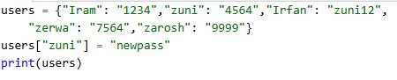
Output:
